



***TEAM LEADER*:**

**1. AYESHA A**

***TEAM MEMBERS*:**

**2. AAYISHA PARVEEN MM**

**3. ARULMARY M**

**4 .NANDHINI B**

***ANALYSING HOUSING PRICES OF METROPOLITAN AREAS IN INDIA***

***PROJECT BASED EXPERIMENTAL LEARNING PROGAM***

1. **Introduction**
   1. Overview

Housing prices in metropolitan areas of India have been a topic of great interest and concern in recent years. With rapid urbanization, population growth, and increased demand for housing, the real estate market in these cities has experienced significant fluctuations. Analyzing housing prices in these metropolitan areas is crucial for various stakeholders, including homebuyers, real estate developers, investors, and policymakers, as it provides valuable insights into market trends, affordability, and economic stability. The housing market in metropolitan areas of India is characterized by its diversity. Each city has its unique dynamics driven by factors such as location, infrastructure development, economic opportunities, and cultural significance. To analyze housing prices effectively, it is essential to consider these distinct aspects and their impact on property values. One of the primary drivers of housing prices in metropolitan India is location. In cities like Mumbai, Delhi, Bangalore, and Chennai, certain neighborhoods are highly sought after due to their proximity to employment hubs, educational institutions, and recreational amenities. In this regard, Tableau is a great choice for analyzing housing prices in metropolitan cities. Tableau helps to explore the trends, compare the prices across the cities based on the amenities by creating visualizations in the form of insightful charts and graphs.

* 1. Purpose

Analysing housing prices can be useful in several ways. It helps potential buyers understand the market trends and make informed decisions about purchasing the property. By studying factors such as the number of bedrooms, proximity of hospitals and schools, presence of staffs and intercom systems, one can understand the factors that influence housing prices. Sellers can also benefit by setting competitive prices based on market demand. It is a way to gain a deeper understanding of the market trends and make smarter choices in real estate industry.

1. **Problem Definition and Design Thinking**
   1. Empathy Map



* 1. Ideation and brainstorming Map

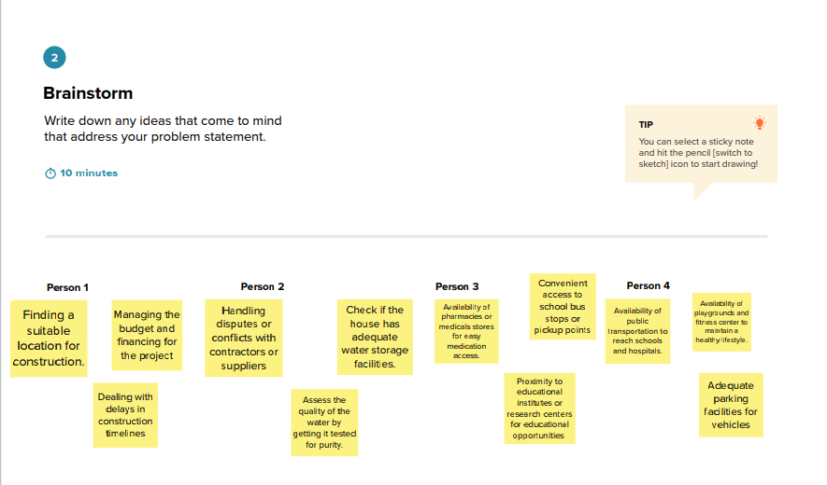

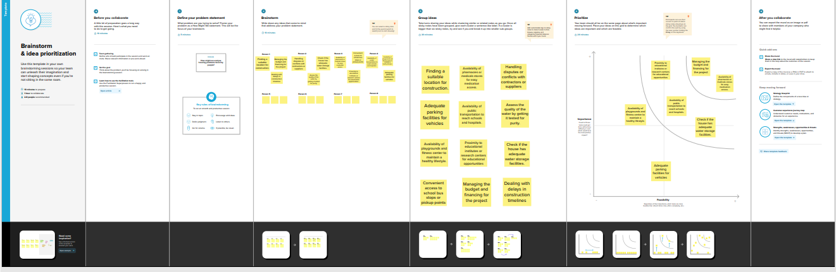

1. **Results**

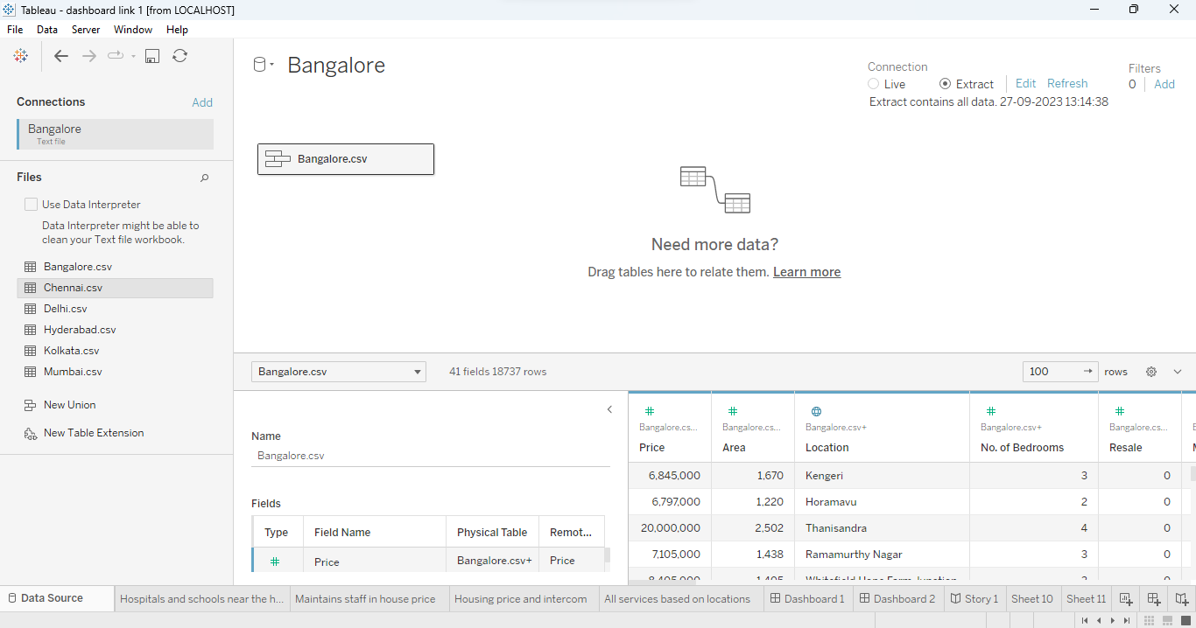

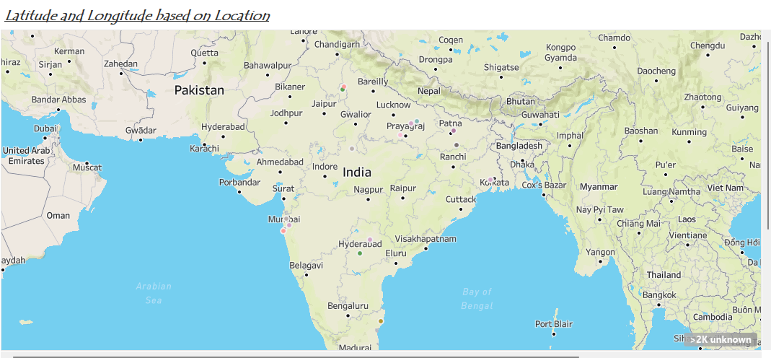

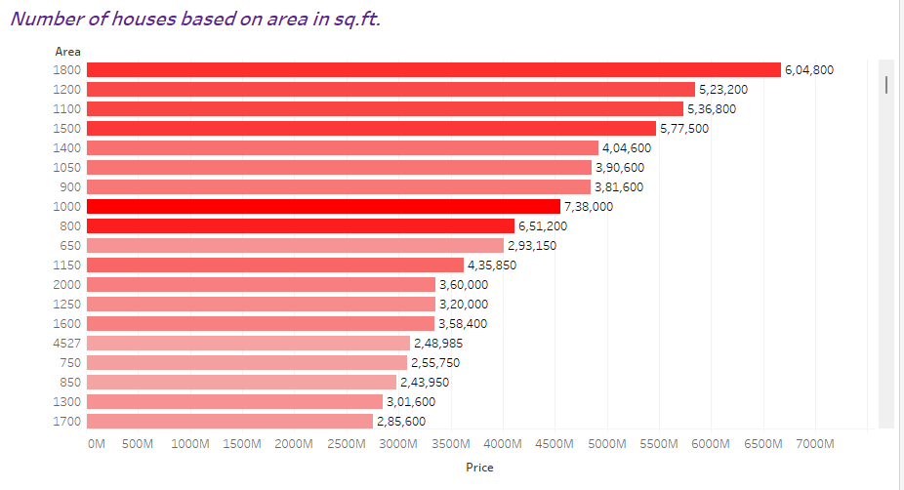

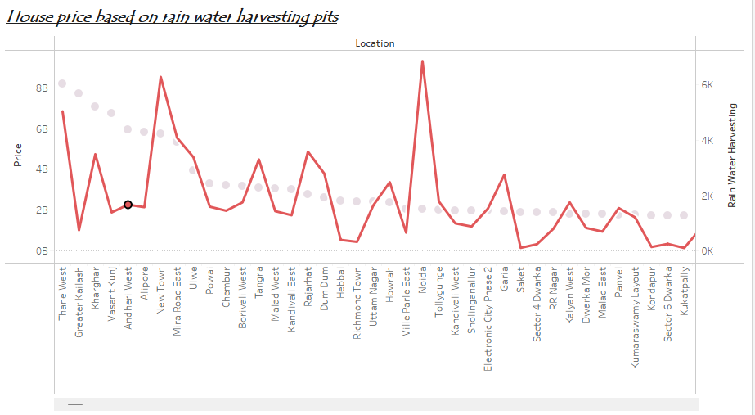

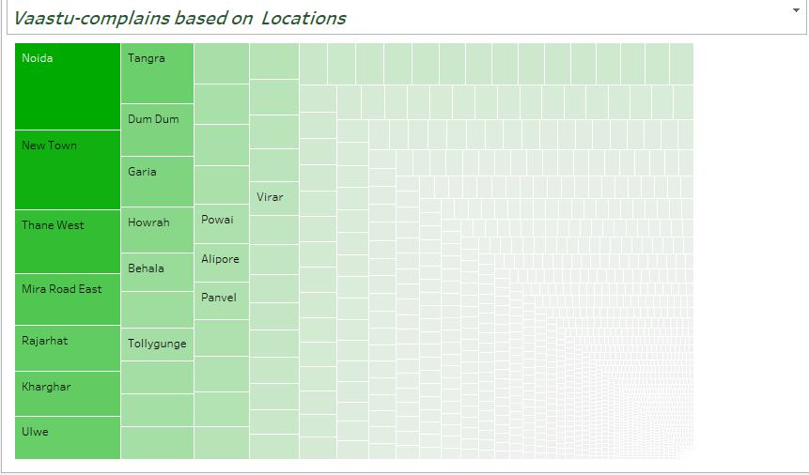

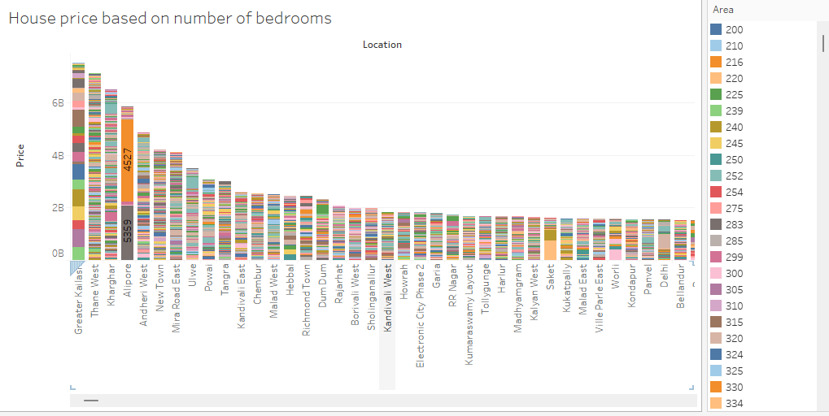

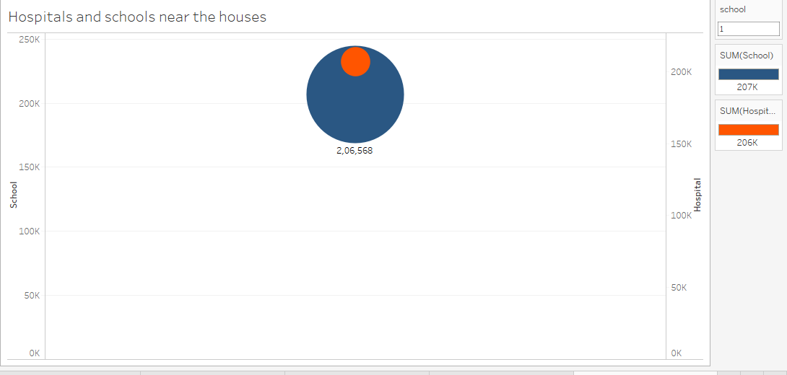

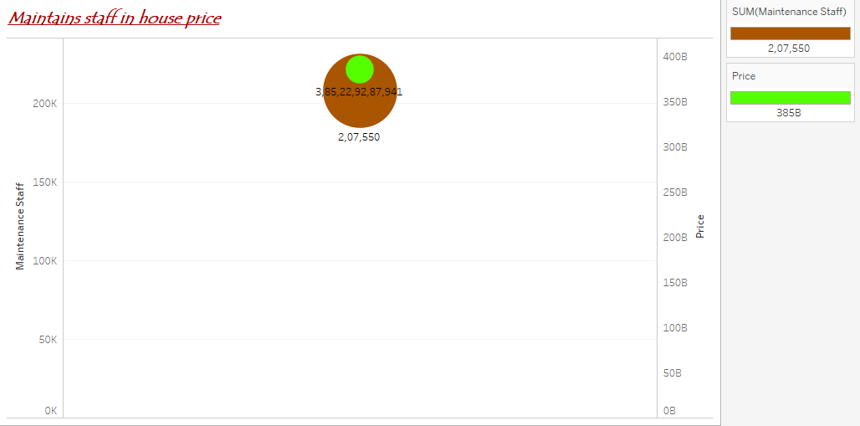

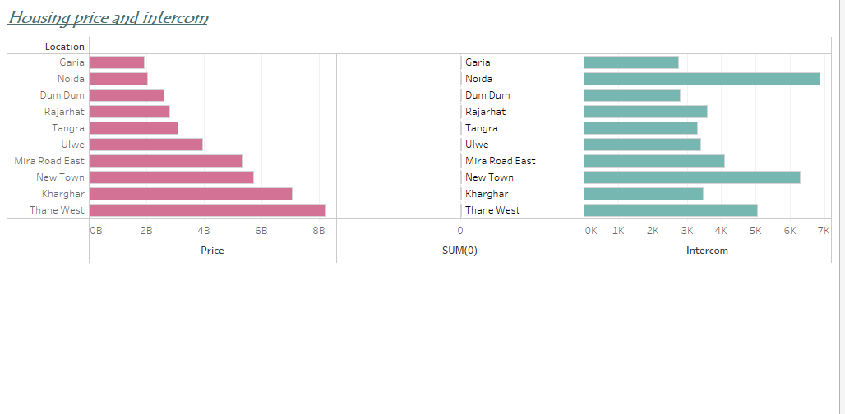

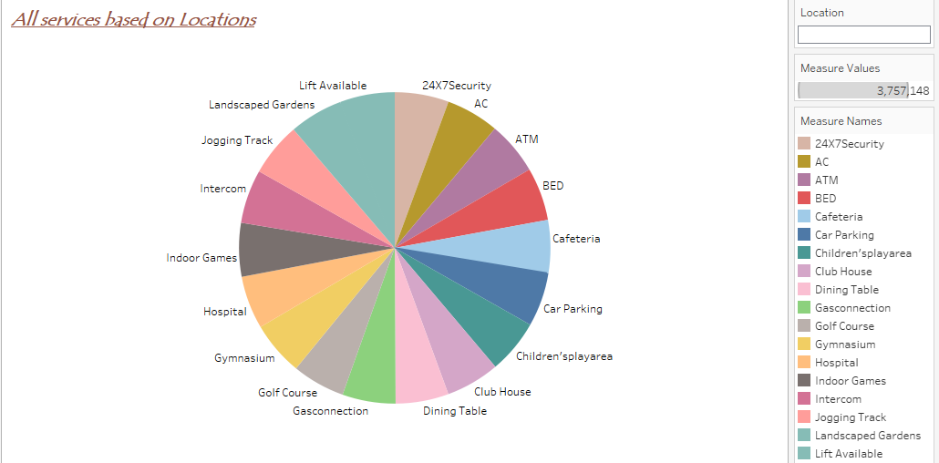

**4. Advantages and Disadvantages**

Advantages of Analyzing Housing Prices in Metropolitan Areas of India:

1. Informed Decision-Making: Buyers and investors can make informed decisions about purchasing or investing in real estate, minimizing the risk of overpaying or making poor investments.
2. Investment Opportunities: Identifying areas with potential for property appreciation allows investors to maximize returns on their investments.
3. Economic Indicator: Housing price trends can serve as an economic indicator, reflecting the overall health and consumer confidence in the economy.
4. Urban Planning: City planners use data to allocate resources efficiently, plan infrastructure development, and address housing demand effectively.
5. Policy Formulation: Governments can formulate housing and tax policies based on housing price analysis, promoting affordability and stability in the real estate market.
6. Financial Planning: Individuals can incorporate housing price data into their financial planning, influencing savings, investments, and retirement decisions.

Disadvantages of Analyzing Housing Prices in Metropolitan Areas of India:

1. Data Reliability: Housing price data may not always be accurate or up-to-date, leading to potential misinterpretations.
2. Speculation: Overreliance on housing price analysis can fuel speculation, leading to market bubbles and subsequent crashes.
3. Displacement: Rapid increases in housing prices can result in the displacement of lower-income residents, causing social and housing inequality issues.
4. Policy Pitfalls: Policies based solely on housing price analysis may overlook broader socioeconomic factors, leading to unintended consequences.
5. Emotional Decisions: Buyers and investors may make impulsive decisions based on short-term price fluctuations, ignoring long-term market fundamentals.
6. Data Access: Limited access to comprehensive housing price data can hinder effective analysis, particularly in less developed regions.
7. **Applications**

The areas where this solution can be applied

Analyzing housing prices has a wide range of applications across various sectors and for different stakeholders.

1. Real Estate Investment: Investors use housing price analysis to identify profitable opportunities, allocate resources effectively, and make informed decisions about buying, holding, or selling properties.
2. Homebuying: Prospective homebuyers rely on housing price data to assess affordability, choose suitable neighborhoods, and negotiate fair prices when purchasing a home.
3. Urban Planning: City planners and policymakers use housing price analysis to guide infrastructure development, allocate resources, and address housing demand to ensure sustainable urban growth.
4. Economic Forecasting: Housing price trends are often considered leading indicators of economic health. Economists use this data to assess economic conditions and predict future trends.
5. Financial Planning: Individuals and families incorporate housing price data into their financial planning to make decisions about savings, investments, and retirement planning.
6. Banking and Lending: Banks and lending institutions use housing price data to assess the value of collateral for mortgage loans and to manage risk in their lending portfolios.
7. Government Policy: Governments formulate housing and tax policies based on housing price analysis to promote affordability, curb speculation, and address housing challenges.
8. Construction and Development: Developers use housing price trends to identify areas with high demand, plan new construction projects, and make decisions about land acquisition.
9. Real Estate Brokerage: Real estate agents and brokers use housing price data to provide clients with insights into market conditions and help them make informed buying or selling decisions.
10. Academic Research: Researchers in fields like economics, sociology, and urban studies use housing price analysis to study housing markets, urbanization trends, and their social implications.
11. **Conclusion**

In conclusion, the analysis of housing prices in metropolitan areas of India is a vital undertaking with far-reaching implications. It serves as a compass guiding a multitude of stakeholders in their decisions, from prospective homebuyers and investors to policymakers and urban planners. By studying housing prices, we gain insights into the dynamics of real estate markets, economic health, and the overall quality of urban life.

This analysis empowers individuals to make informed choices about homeownership, helps investors allocate resources wisely, and enables governments to craft effective policies that address housing affordability and market stability. Furthermore, housing price analysis contributes to sustainable urban development by guiding infrastructure planning and promoting equitable access to housing opportunities.

However, it is crucial to recognize that housing price analysis is not without its challenges. Data accuracy, speculation, and potential social repercussions must be carefully considered. Nevertheless, when approached thoughtfully and holistically, housing price analysis remains an invaluable tool for fostering healthy, inclusive, and economically vibrant metropolitan areas in India. It provides a roadmap for navigating the complex landscape of real estate, ensuring that housing markets serve the needs of both residents and the broader economy.

1. **Future Scope**

Enhancements that can be made in the future.

The future scope for enhancing the analysis of housing prices in metropolitan areas of India is promising, as technology and data availability continue to evolve.

1. Advanced Data Analytics: The use of artificial intelligence and machine learning algorithms can enable more accurate predictions of housing price trends. These technologies can identify subtle patterns and factors that influence prices, providing more precise insights for decision-makers.
2. Predictive Modeling: Predictive modeling can be used to forecast future housing price trends based on historical data and a variety of economic, demographic, and urban development factors. This can aid in long-term planning and investment strategies.
3. Blockchain Technology: Implementing blockchain technology for property transactions can enhance transparency and reduce fraud in the real estate sector. This can lead to more reliable data for analysis.
4. Environmental and Sustainability Metrics: Future analysis could include factors related to environmental sustainability, such as green building certifications and proximity to eco-friendly amenities, which are becoming increasingly important to homebuyers.
5. Mobile Apps and Tools: Develop user-friendly mobile apps and online tools that allow homebuyers and investors to access real-time housing price data and conduct personalized analyses.
6. Community Engagement: Involve communities and residents in the analysis process by collecting their insights and preferences, which can be valuable in understanding the local housing market dynamics.

The future of analyzing housing prices in metropolitan areas of India holds tremendous potential for innovation and improvement. Leveraging technology, data analytics, and a more holistic approach to data collection can lead to more accurate, timely, and socially responsible analyses, benefiting all stakeholders involved in the housing market.

